The Relationship between Law and Grace


Mount Calvary
Mount Sinai
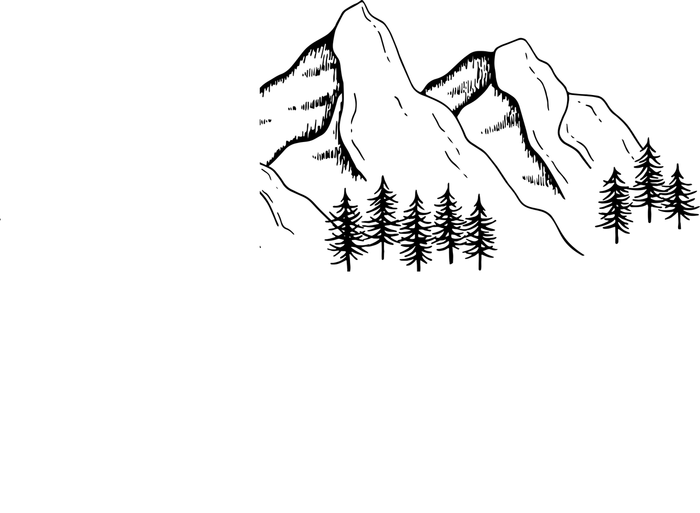
The law, given on Mt. Sinai, drives us to God's grace, manifested on Mt. Calvary!

